Unit Testing

Simple Calculator

Version 1.0

Prepared by:

Ashiwin

2 December 2014

Table of Contents

Section 1: Test Cases 3

Section 2: Screenshots 4

Test Case SC_1.01 – Pass 4

Test Case SC_1.02 – Pass 5

Test Case SC_1.03 – Pass 6

Test Case SC_2.01 – Pass 7

Test Case SC_2.02 – Pass 8

Test Case SC_2.03 – Pass 9

Test Case SC_3.01 – Pass 10

Test Case SC_3.02 – Pass 11

Test Case SC_3.03 – Pass 12

Test Case SC_3.04 – Pass 13

Test Case SC_3.05 – Pass 14

Test Case SC_3.06 – Pass 15

Test Case SC_4.01 – Pass 16

# Section 1: Test Cases

|  |  |  |  |  |  |  |  |
| --- | --- | --- | --- | --- | --- | --- | --- |
| **Case #** | **Function** | **Action** | **Expected Result** | **Actual Result** | **Status** | **Tested By** | **Date** |
| SC_1.01 | *x* | Key in an integer for *x* | System will proceed with *y* | System proceeds with *y* | Pass | Ashiwin | 02/12/2014 |
| SC_1.02 | *x* | Key in a decimal for *x* | System will proceed with *y* | System proceeds with *y* | Pass | Ashiwin | 02/12/2014 |
| SC_1.03 | *x* | Key in an alphabet for *x* | Error message will appear | Error message appears | Pass | Ashiwin | 02/12/2014 |
| SC_2.01 | *y* | Key in an integer for *y* | System will proceed with operator | System proceeds with operator | Pass | Ashiwin | 02/12/2014 |
| SC_2.02 | *y* | Key in a decimal for *y* | System will proceed with operator | System proceeds with operator | Pass | Ashiwin | 02/12/2014 |
| SC_2.03 | *y* | Key in an alphabet for *y* | Error message will appear | Error message appears | Pass | Ashiwin | 02/12/2014 |
| SC_3.01 | Operator | Key in 1 for addition | Correct result of addition will be displayed | Correct result of addition is displayed | Pass | Ashiwin | 02/12/2014 |
| SC_3.02 | Operator | Key in 2 for subtraction | Correct result of subtraction will be displayed | Correct result of subtraction is displayed | Pass | Ashiwin | 02/12/2014 |
| SC_3.03 | Operator | Key in 3 for multiplication | Correct result of multiplication will be displayed | Correct result of multiplication is displayed | Pass | Ashiwin | 02/12/2014 |
| SC_3.04 | Operator | Key in 4 for division | Correct result of division will be displayed | Correct result of division is displayed | Pass | Ashiwin | 02/12/2014 |
| SC_3.05 | Operator | Key in numbers other than 1,2,3 or 4 | Error message will appear | Error message appears | Pass | Ashiwin | 02/12/2014 |
| SC_3.06 | Operator | Key in an alphabet | Error message will appear | Error message appears | Pass | Ashiwin | 02/12/2014 |
| SC_4.01 | Miscellaneous | Perform division by zero | Error message will appear | Error message appears | Pass | Ashiwin | 02/12/2014 |

# Section 2: Screenshots

## Test Case SC_1.01 – Pass

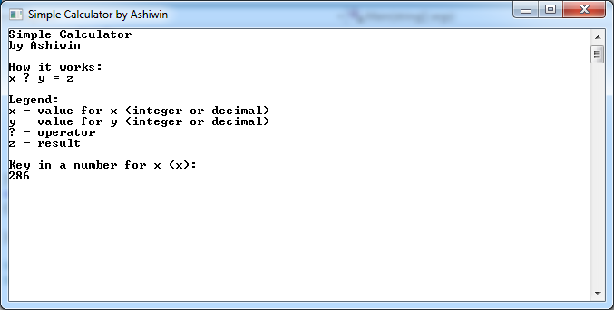

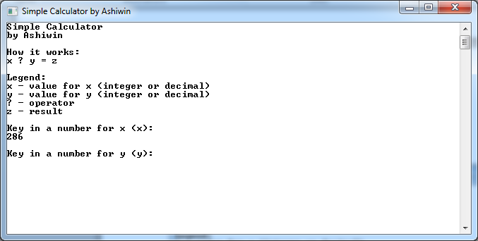

## Test Case SC_1.02 – Pass

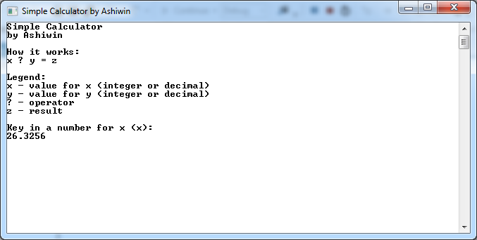

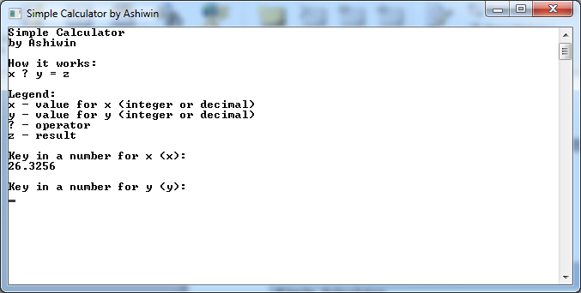

## Test Case SC_1.03 – Pass

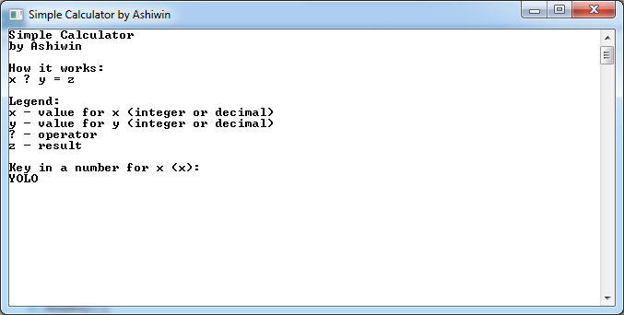

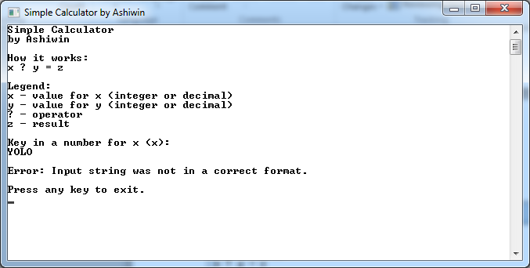

## Test Case SC_2.01 – Pass

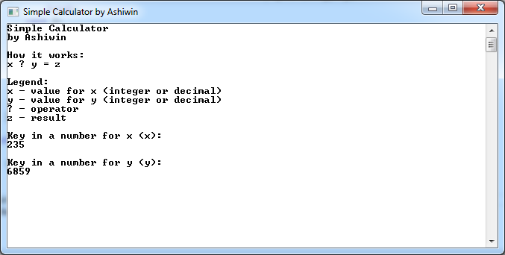

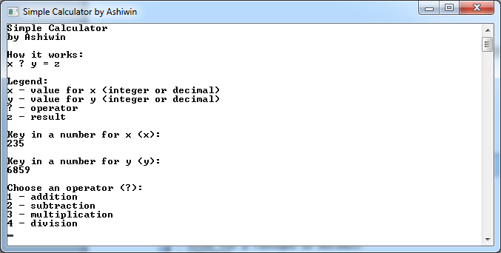

## Test Case SC_2.02 – Pass

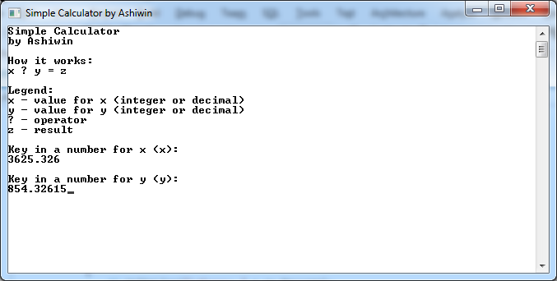

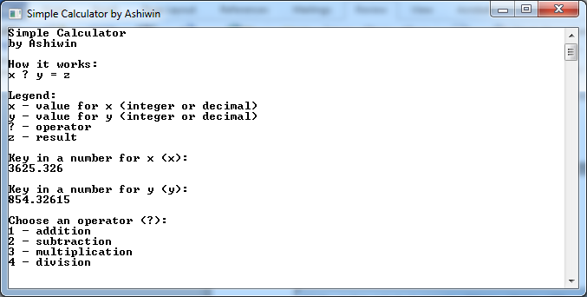

## Test Case SC_2.03 – Pass

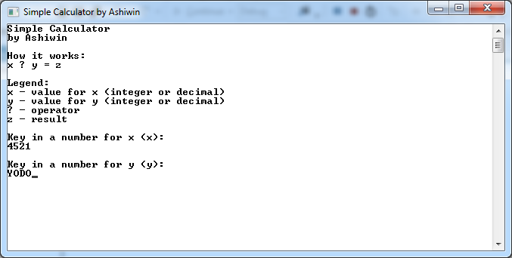

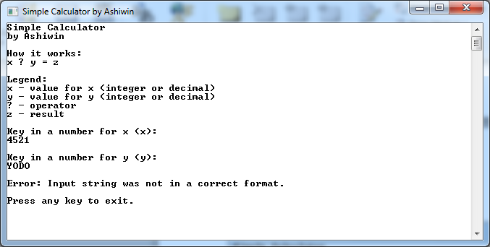

## Test Case SC_3.01 – Pass

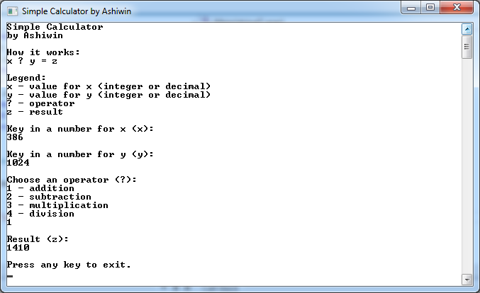

## Test Case SC_3.02 – Pass

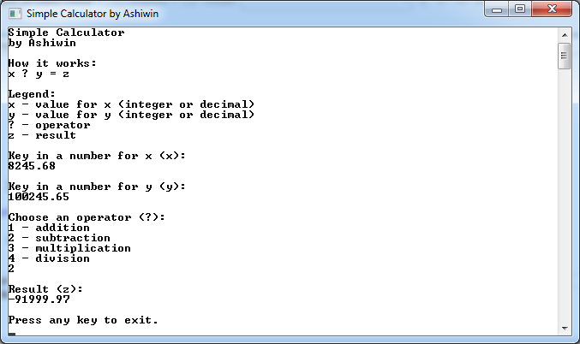

## Test Case SC_3.03 – Pass

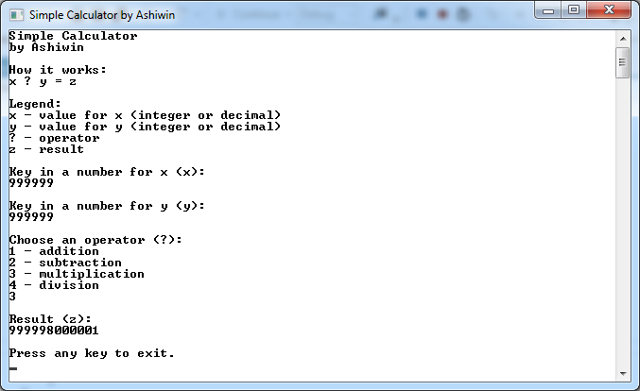

## Test Case SC_3.04 – Pass

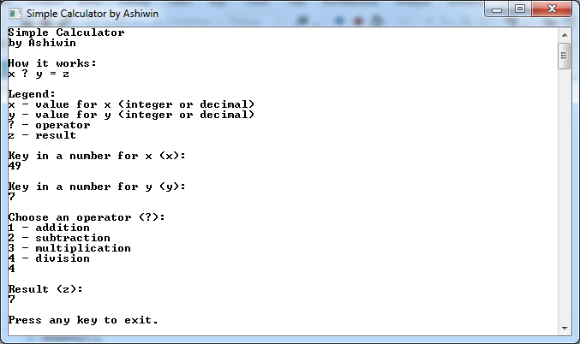

## Test Case SC_3.05 – Pass

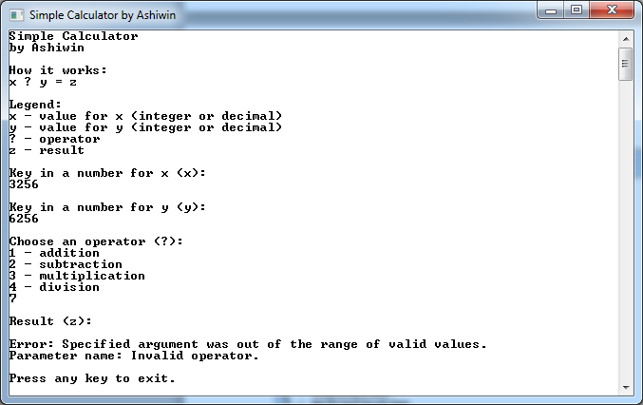

## Test Case SC_3.06 – Pass

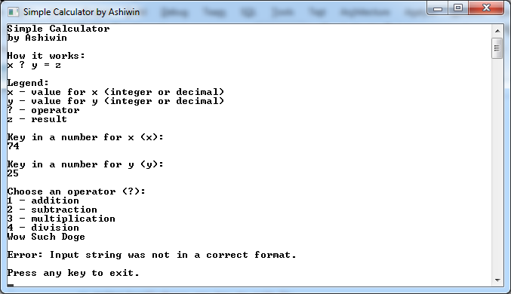

## Test Case SC_4.01 – Pass

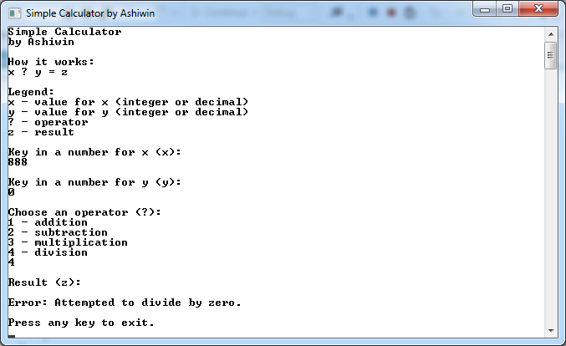

**End of Document**